2024 American Heart Month Communication Toolkit:
Promoting Heart Health

February is American Heart Month, a time when all people are encouraged to focus on their cardiovascular health. Heart disease is the leading cause of death for men, women, and people of most racial and ethnic groups in the United States.

In most cases, heart disease is preventable when people adopt a healthy lifestyle, which includes not smoking, maintaining a healthy weight, controlling blood sugar and cholesterol, treating high blood pressure, getting at least 150 minutes of moderate-intensity physical activity a week, eating a heart-healthy diet, and getting regular checkups.

This toolkit contains sample social media posts and graphics, and newsletter/blog articles in English and Spanish. To help raise awareness of the importance of heart health, we ask that you use this toolkit to share messages through your communication and social media networks during February.

Raise Awareness for These Observances

Observance |  | Date |  | Hashtag
 | American Heart Month |  | February 2024 |  | #HeartMonth
 | National Wear Red Day |  | February 3, 2024 |  | #WearRedDay
 | Valentine’s Day |  | February 14, 2024 |  | #ValentinesDay

SAMPLE NEWSLETTER/BLOG ARTICLES
Copy and paste or edit as appropriate to meet the needs of the families and clients that you serve.

Article 1

English

February is Heart Month!
Heart disease is the leading cause of death for both men and women in the United States. The good news? Heart disease is also preventable. The Southern Nevada Health District’s Office of Chronic Disease Prevention and Health Promotion have put together some heart-healthy lifestyle tips you can use to protect your heart.
- Be more physically active.
- Maintain a healthy weight.
- Eat a nutritious diet.
- Quit smoking.
- Reduce stress.
- Get 7-9 hours of quality sleep.
- Track your heart health stats. Manage Your Risk.
You don’t have to make big changes all at once. Small steps will get you where you want to go.
Spanish

¡Febrero es el Mes del Corazón!

La enfermedad cardíaca es la principal causa de muerte tanto para hombres como para mujeres en los Estados Unidos. ¿Las buenas noticias? También es una de las más prevenibles. La Oficina de Prevención de Enfermedades Crónicas y Promoción de la Salud del Distrito de Salud del Sur de Nevada ha reunido algunos consejos para un estilo de vida saludable que puede utilizar para proteger su corazón.

- Sea más activo físicamente.
- Mantenga un peso saludable.
- Consuma una dieta nutritiva.
- Deje de fumar.
- Reduzca el estres.
- Duerma entre 7 y 9 horas de calidad.
- Realice un seguimiento de las estadísticas de salud de su corazón. Administre su riesgo.

No es necesario realizar grandes cambios a la misma vez. Pequeños pasos lo llevarán a donde quiera llegar.

Article 2
English

Take Care of Your Heart This Valentine’s Day!

Valentine’s Day is all about romance and showing those you love how much you care. This year show your loved ones you care by taking care of their heart this Valentine’s Day. Focus on having a healthy Valentine’s Day celebration and keep your New Year’s goals in mind. Here are some tips to help you think heart healthy this holiday:
Skip the sweets and treats. If your special valentine is focused on maintaining a healthy weight, consider purchasing strawberries or a fruit basket/arrangement instead of the traditional box of chocolates. Consider a gift that doesn’t involve food like a bouquet of flowers, healthy cookbook, personal training sessions or a day spa gift certificate. Even a homemade valentine card and some quality time can be a meaningful way to show your affection.
Dine in. A great way to save calories, money and avoid crowds is to cook a meal at home. Find a healthy meal that you can cook and enjoy a healthier dessert that involves fruit like this raspberry chocolate mini macarons or check out these heart healthy recipes.

Keep it moderate. Valentine’s Day is a time for laughter, fun and food. Having a small slice of cake or a truffle will not ruin your goals. Moderation is key. And if you receive some chocolates or treats on the special day, share them with others or enjoy them in moderation over the next several weeks.
Swap the treats. If your kids are having a Valentine’s Day party at their school or day care, instead of sending candies, consider raisins, grapes, whole-grain pretzels, colored pencils or stickers as tokens of their friendly affection.
Take a long, romantic walk with your loved one – and try to make it a regular habit. Aim for at least 150 minutes of moderately intense physical activity each week to help keep your heart healthy. You can reach this goal by walking briskly for at least 30 minutes five days each week.
Spanish
¡Cuide su corazón este día de San Valentín!
El Día de San Valentín se trata de romance y de mostrar a quienes amas cuánto te importan. Este año demuestra a sus seres queridos que le importa el cuidado de su corazón este Día de San Valentín. Concéntrese en tener una celebración saludable del Día de San Valentín y tenga en cuenta sus objetivos de Año Nuevo. A continuación, se ofrecen algunos consejos que le ayudarán a mantener un corazón saludable durante esta festividad:
Evite los dulces y golosinas. Si su San Valentín especial se centra en mantener un peso saludable, considere comprar fresas o una canasta o arreglo de frutas en lugar de la tradicional caja de chocolates. Considere un regalo que no implique comida, como un ramo de flores, un libro de cocina saludable, sesiones de entrenamiento personal o un certificado de regalo de spa. Incluso una tarjeta de San Valentín hecha en casa y pasar un rato agradable pueden ser una forma significativa de mostrar su afecto.
Cene en casa. Una excelente manera de ahorrar calorías, dinero y evitar multitudes es cocinar una comida en casa. Encuentra una comida saludable que pueda cocinar y disfrute de un postre más saludable que incluya frutas como tarta de fresas. Vea algunas recetas saludables para el corazón.
Mantenlo moderado. El día de San Valentín es un momento de risas, diversión y comida. Comer un pequeño trozo de tarta o una trufa no arruinará sus objetivos. La moderación es clave. Y si recibe algunos chocolates o golosinas en ese día especial, compártalos con otras personas o disfrútelos con moderación durante las próximas semanas.
Intercambie las golosinas. Si sus hijos van a celebrar una fiesta de San Valentín en su escuela o guardería, en lugar de enviarles dulces, considere pasas, uvas, galletas integrales, lápices de colores o calcomanías como muestras de su afecto amistoso.
Dé un paseo largo y romántico con su ser querido y trate de convertirlo en un hábito. Intente realizar al menos 150 minutos de actividad física moderadamente intensa cada semana para ayudar a mantener su corazón sano. Puede alcanzar este objetivo caminando rápidamente durante al menos 30 minutos cinco días a la semana.

Article 3
Taking the Barbershop Experience Beyond the Chair
In the United States, an estimated 59% of Black women 44% of Black men are living with some form of cardiovascular disease. In an effort to address disparities in hypertension and diabetes in the African American community the Southern Nevada Health District’s Office of Chronic Disease Prevention and Health Promotion created the Barber/Beauty Shop Health Outreach Program (BSHOP/BeSHOP) Initiative. The program started as a pilot program in 2018 with 3 participating barbershops. Since then, the program has grown to include 11 Black-owned barbershops and 4 Black-owned beauty shops. Through regular in-shop outreach, the CDPP team and volunteers provide blood pressure and prediabetes screening, education, and referral.
The approach is tailored to meet the needs of the African American community. Barber and Beauty shops are important partners in the BSHOP/BeSHOP initiative. CDPP staff trains both the owners and the barbers and stylists as part of the initiative. Through this partnership, the barbers and stylists become advocates for blood pressure and prediabetes screening and encourage participation among their clients. The BSHOP/BeSHOP program has also grown to include new program components including community screenings, barber-led community walks, and Shop Talk events. In the last year, over 650 people received blood pressure and prediabetes screening, education, and referral in one of the participating BSHOP locations. To find BSHOP screenings, visit the community calendar on the Get Healthy Clark County website.

SAMPLE SOCIAL MEDIA POSTS
Share these social media messages with your followers. Don’t forget to tag @GetHealthyClarkCounty and @Viva SaludableSNV in your posts and follow us on social media. Copy and paste or edit as appropriate to meet the needs of the families and clients that you serve. These are just sample posts. Feel free to use or create your own.

American Heart Month

English | Spanish
When was the last time you had your blood pressure checked? Let this serve as your reminder to get it checked and send it to someone else who needs the reminder too.  (Use graphic 1 with this post) | ¿Cuándo fue la última vez que le revisaron la presión arterial? Deje que esto le sirva como recordatorio para revisárselo y envíele esto a otra persona que también necesite el recordatorio.
Cardiovascular diseases are the leading cause of death and disability worldwide. A way to prevent heart disease is not smoking or using tobacco. Call the Nevada Tobacco Quitline at 1-800-QUIT-NOW or (1-800-784-8669) from a Nevada area code for free resources and support.  (Use graphic 2 with this post) | Las enfermedades cardiovasculares son la principal causa de muerte y discapacidad en todo el mundo. Una forma de prevenir enfermedades cardíacas es no fumando ni consumiendo tabaco. Para obtener recursos gratuitos Llame a la Línea de Ayuda Para Dejar de Fumar de Nevada al 1-855-DÉJELO-YA (1-855-335-3569) o envía el mensaje de texto DÉJELO-YA al 333888.
Your heart is counting on you. Heart disease is the leading cause of death in the U.S. The simple process of checking and recording your blood pressure at least twice a month over a period of four months has been shown to lower blood pressure in some people with hypertension. Blood Pressure Self-Monitoring is an evidence-based program that features personalized support for developing a blood pressure self-monitoring routine, tips for maintaining cardiovascular health and nutrition education. https://www.lasvegasymca.org/dev/wp-content/uploads/2022/03/BPSM-Flyer-General.pdf  (Use graphic 3 with this post) | Su corazón cuenta con usted. La enfermedad cardíaca es la principal causa de muerte en los EE. UU. Se ha demostrado que el simple proceso de revisar y registrar la presión arterial al menos dos veces al mes durante un período de cuatro meses reduce la presión arterial en algunas personas con hipertensión. El autocontrol de la presión arterial es un programa basado en evidencia que ofrece apoyo personalizado para desarrollar una rutina de autocontrol de la presión arterial, consejos para mantener la salud cardiovascular y educación nutricional. https://www.lasvegasymca.org/dev/wp-content/uploads/2022/03/2022-BPSM-11x17-Flyer-SNHD-SPANISH.pdf  (Use Graphic 1 in Spanish with this post)
Our hearts are healthier when we have important conversations with a healthcare provider. Stay up to date on your doctors’ appointments & medications. Have your blood pressure, blood sugar, & cholesterol levels checked and know what your numbers mean for your risk for heart disease. | Nuestros corazones están más sanos cuando tenemos conversaciones importantes con un proveedor de atención médica. Manténgase actualizado sobre las citas y medicamentos de sus médicos. Revise los niveles de presión arterial, azúcar en la sangre y colesterol y sepa qué significan sus cifras para su riesgo de enfermedad cardíaca.
Heart disease and stroke continue to be among the top causes of death in Nevada. Healthcare providers can play a big role in helping their patients reduce their risk. The Southern Nevada Health District has developed resources addressing heart disease, stroke, and high-blood pressure for providers. Check them out here: https://gethealthyclarkcounty.org/community-tools/healthcare/

Suggested hashtags:
#CardiovascularDisease
#HeartMonth

SAMPLE SOCIAL MEDIA GRAPHICS

Graphic 1
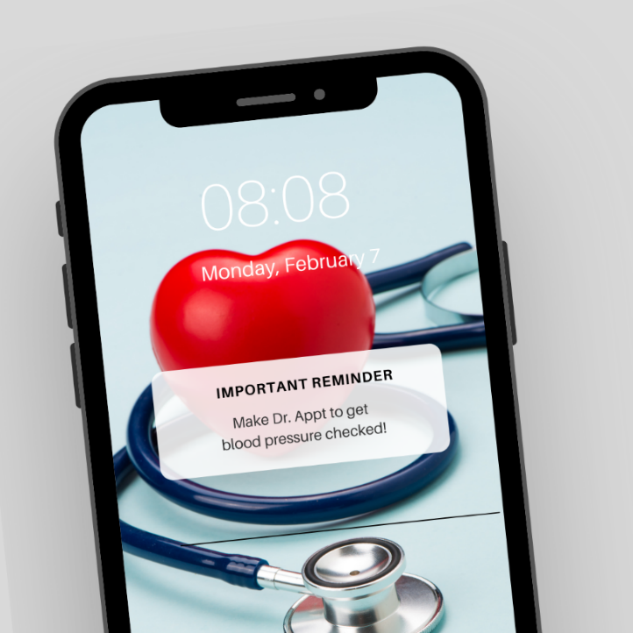

Graphic 2
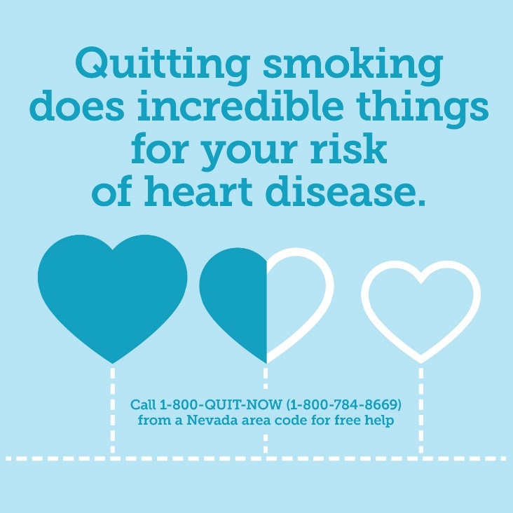

Graphic 3
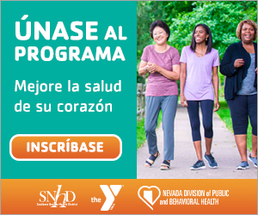

OTHER RESOURCES

- Centers for Disease Control and Prevention American Heart Month 2024 Toolkits
- National Heart Blood and Lung Institute Toolkit
- Wear Red Day

